/\*------------------------------------------------------------------------------------

Programming Assignment 5 Submission

Sorting Algorithms - Sort arrays in ascending order using Selection Sort at O(n^2)

and O(nk) time complexities and finding the median value

using k index.

Created by Hyo Lee

Student ID: 002292770

02/09/2016

-------------------------------------------------------------------------------------\*/

1.

Sort at O(n^2) using sample test case as provided.

Input: { 4, 6, 8, 15, 20, 22, 10, 3, 9, 2 }

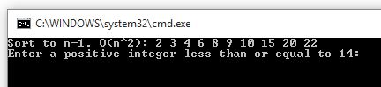

Sort at O(n^2) using a set with negative, repeating, and decimal numbers.

Input: { 2, 7, 4, 1, 5, 6, 3.2, 3, 2, -10 } 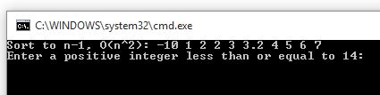

2.

Sort at O(nk) using sample test case provided.

K = 4

Input: { 4, 6, 8, 15, 20, 22, 10, 3, 9, 2 }

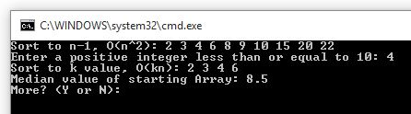

Sort at O(nk) using sample test case provided.

K = 6

Input: { 4, 6, 8, 15, 20, 22, 10, 3, 9, 2 }

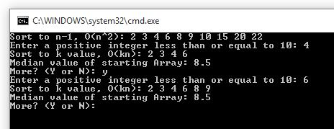

Sort at O(nk) using a set with negative and decimal numbers.

K = 14

Input: { 6, -4, 9, 15, 20, 22, 10, 3, 44, 2.2, 11, 4, 5, 1 }

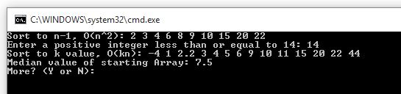

3. Find the Median value of the starting array.

Median value of even set. Correct as 8.5.

Input: { 4, 6, 8, 15, 20, 22, 10, 3, 9, 2 }



Median value of odd set. Correct as 9.

Input: { 4, 6, 8, 15, 20, 22, 10, 3, 9 }

